Vendor Performance Analytics project

**Business Problem**

Effective inventory and sales management are critical for optimizing profitability in the retail and wholesale industry. Companies need to ensure that they are not incurring losses due to inefficient pricing, poor inventory turnover, or vendor dependency. The goal of this analysis is to:

* Identify underperforming brands that require promotional or pricing adjustments.
* Determine top vendors contributing to sales and gross profit.
* Analyze the impact of bulk purchasing on unit costs.
* Assess inventory turnover to reduce holding costs and improve efficiency.
* Investigate the profitability variance between high-performing and low-performing vendors.

**Exploratory Data Analysis Insights**

**Summary Statistics**

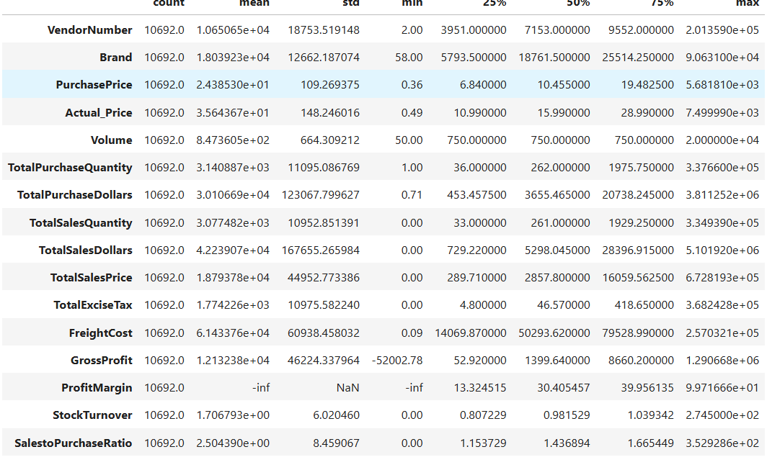

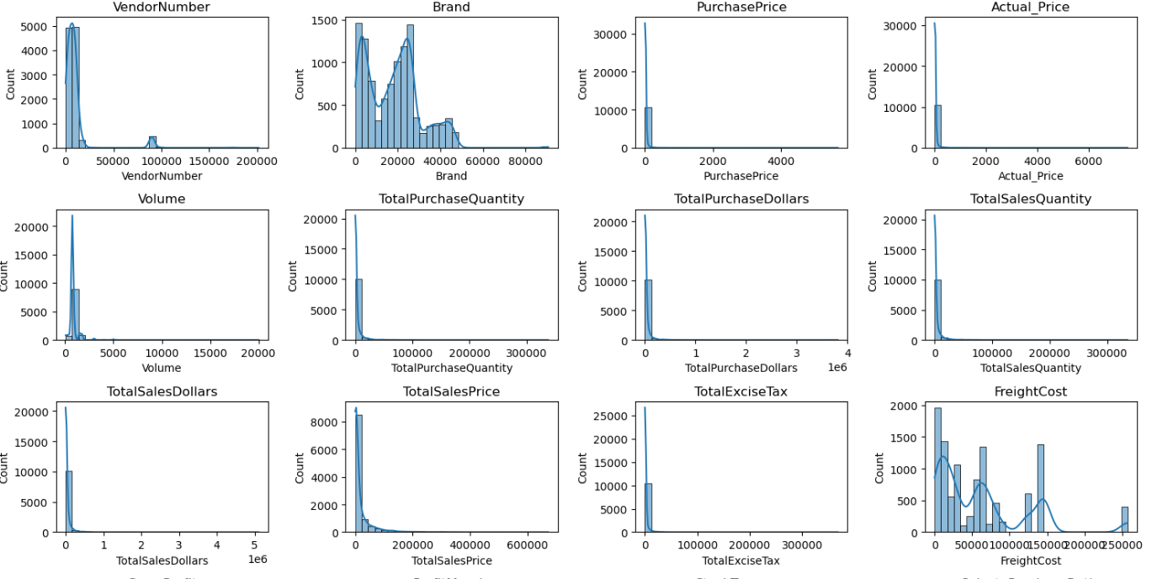

**Negative & Zero Values:**

1. **Gross Profit:** Minimum of -52,002.78, indicating potential high costs or heavy discounts. This could be due to selling products at lower prices than their purchase costs.
2. **Profit Margin:** Has a minimum of -∞, which suggests instances where revenue is zero or even lower than the total cost, leading to extreme negative profit margins.
3. **Total Sales Quantity & Sales Dollars:** Some products show zero sales, indicating they were purchased but never sold. These may be slow-moving or obsolete stock, leading to inventory inefficiencies.

**Outliers Detected by High Standard Deviations:**

**Purchase & Actual Prices:** The maximum values (5,681.81 & 7,499.99) are significantly higher than the mean (24.39 & 35.64), indicating premium product offerings.

**Freight Cost:**

**Extreme variation from 0.09 to 257,032.07** suggests logistics inefficiencies, bulk shipments, or erratic shipping costs across different products.

**Stock Turnover:**

**Ranges from 0 to 274.5**, suggesting some products sell rapidly while others remain unsold for long periods. A value greater than 1 indicates that sales for a product exceed the purchased quantity due to older stock fulfilling orders.

Data Filtering:

To Enhance the reliability of the insights , we removed inconsistent data points where:

Gross Profit <=0 (to exclude transactions leading to losses)

Profit Margin <=0 (to ensure Analysis focuses on profitable transactions)

Total Sales Quantity =0 (to eliminate Inventory that was never Sold)

Co-Relation Insights

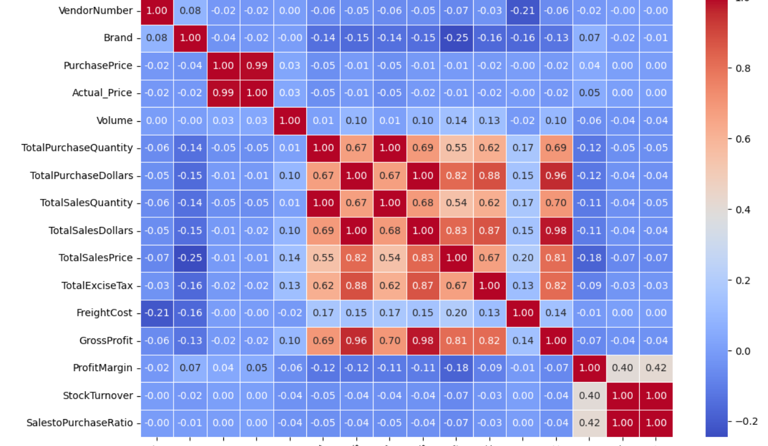

1. PurchasePrice has weak correlations with TotalSalesDollars (-0.012) and GrossProfit (-0.016), suggesting that price variations do not significantly impact sales revenue or profit.
2. Strong correlation between total purchase quantity and total sales quantity (0.999), confirming efficient inventory turnover.
3. Negative correlation between profit margin & total sales price (-0.179) suggests that as sales price increases, margins decrease, possibly due to competitive pricing pressures.
4. StockTurnover has weak negative correlations with both GrossProfit (-0.038) and ProfitMargin (-0.055), indicating that faster turnover does not necessarily result in higher profitability.

**Research Questions AND Key Findings**

1. **Brans For Promotional Pricing and Adjustments**

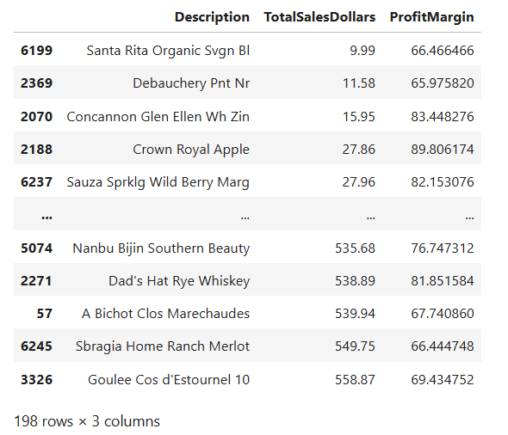

198 Brands exhibit lower Sales but higher profit Margin

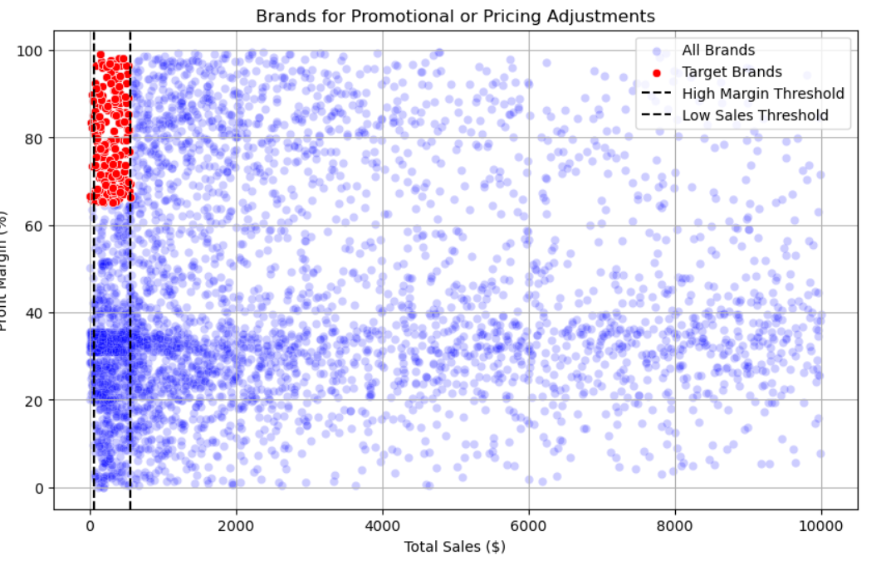

1. Top Vendors by Purchase and Sales Contribution

The top 10 vendors contribute **65.69% of total purchases**, while the remaining vendors contribute only **34.31%**.  
This over-reliance on a few vendors may introduce risks such as supply chain disruptions, indicating a need for diversification.

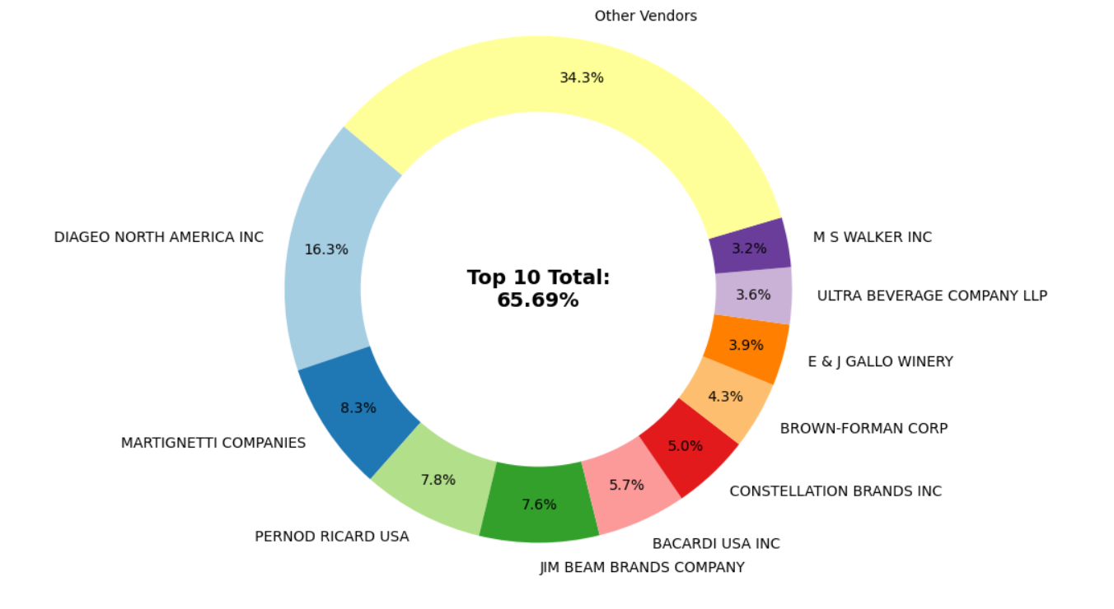

3.Vendor Contribution to Total Purchase Dollars

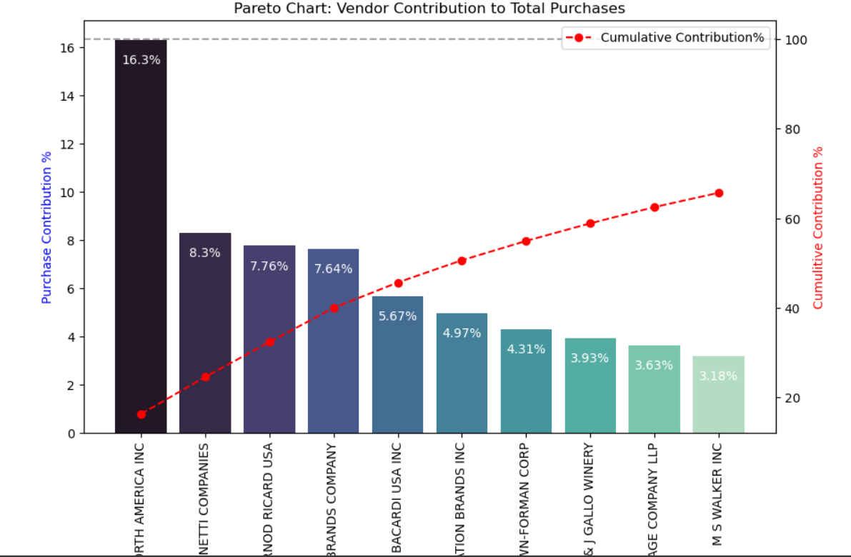

4.Vendors and Brands with Higher Sales Performances

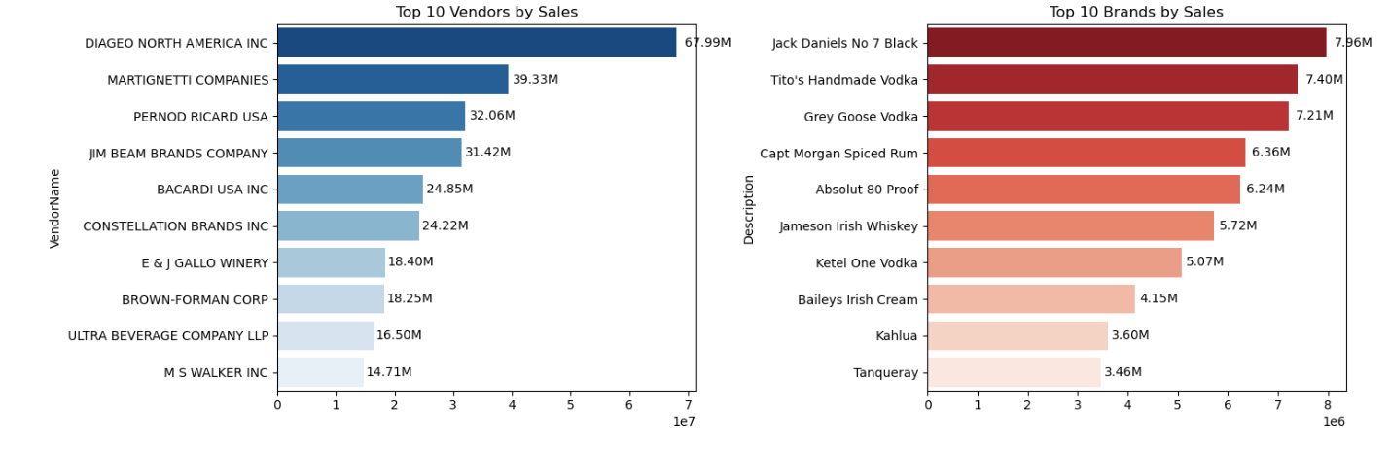

5.Confidence Interval comparison: Top vs Low Vendors (Profit margin)

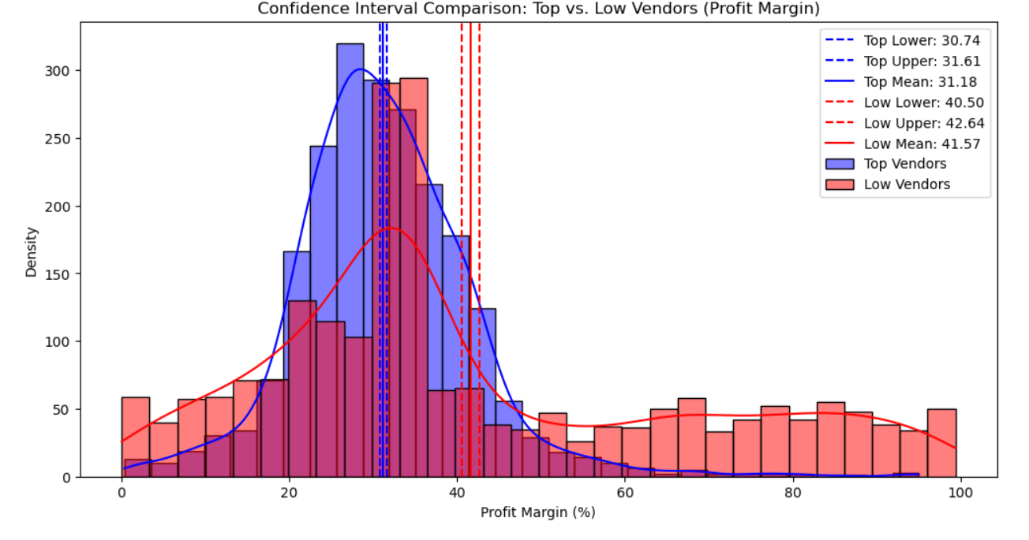

1. The confidence interval for low-performing vendors (40.48% to 42.62%) is significantly higher than that of top-performing vendors (30.74% to 31.61%).
2. This suggests that vendors with lower sales tend to maintain higher profit margins, potentially due to premium pricing or lower operational costs.
3. For High-Performing Vendors: If they aim to improve profitability, they could explore selective price adjustments, cost optimization, or bundling strategies.
4. For Low-Performing Vendors: Despite higher margins, their low sales volume might indicate a need for better marketing, competitive pricing, or improved distribution strategies.

Final Recommendations:

1. Re-evaluate pricing for low -sales, high-margin brands to boost sales volume without sacrificing Profitability.
2. Diversify vendor partnerships to reduce dependency on a few suppliers and mitigate supply chain risks.
3. Leverage bulk purchasing advantages to maintain competitive pricing while optimizing inventory management.
4. Optimize slow-moving inventory by adjusting purchase quantities, launching clearance sales, or revising storage strategies.
5. Enhance marketing and distribution strategies for low-performing vendors to drive higher sales volumes without compromising profit margins.
6. By implementing these recommendations, the company can achieve sustainable profitability, mitigate risks, and enhance overall operational efficiency.